Barnhill Memorial School
Welcome to Barnhill! There are a few things you need to know about our school. For example, have you heard of B.O.L.T? At Barnhill B.O.L.T stands for:
- Being Respectful
- Owning your Learning
- Living Safely
- Taking Responsibility
Barnhill students are expected to follow the B.O.L.T principles. Doing so will set them up for a successful year in middle school.
Students are regularly recognized for meeting B.O.L.T expectations and successful students will participate in PBIS (Positive Behaviour Intervention Supports) initiatives throughout the school year.
At Barnhill Memorial School -
We do our BEST!
Better
Every
Single
Time

Information for Lightning Families
School supplies and other vital information can be found on our website. You can find us at: http://barnhill.nbed.nb.ca
You can also follow us on Twitter: @BarnhillASD
Families will receive The Lightning News weekly via PowerPoint emailed each Friday afternoon with the information for the following week.
Homeroom begins at 8:25 am. Dismissal is at 2:55 pm. For the safety of our students, Barnhill Memorial School is a closed campus.
At Barnhill, each student will have a locker. Locks will be issued to students by their homeroom teacher after the student fee has been paid.
Parents & guardians who drive students to school are asked to use the Drop Off Zone at the epitaph between St. Rose and Barnhill Memorial School. Look and listen before you exit your car. Please do your part to keep traffic moving and everyone safe.
Administration
Principal Ms. Jill Ferguson
P: 506-658-5971
E: jill.ferguson@nbed.nb.ca

Vice Principal Mrs. Melissa Lisik
P: 506-658-5972
E: melissa.lisik@nbed.nb.ca

Welcome
To
Barnhill
Memorial
School
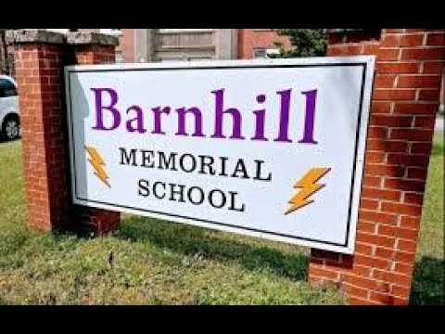
Home of Larry the Lightning Bolt
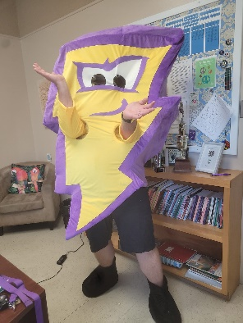

Morning
In the morning, all our students will remain supervised outside until 8:20 a.m. Upon entering the school, they will go to their lockers to organize their belongings and then report to their homeroom at 8:25am. Late arrivals please come to the office to sign in.
Safe Arrivals Program
Report your child’s absence using any of these methods: *Call toll free: 1-833-219-9065 *Website: https:go/schoolmessenger.com *Mobile app: SchoolMessenger

Daily Healthy Breakfast
Each day as students enter, they are welcome to enjoy a healthy breakfast item at Barnhill’s grab and go style breakfast. Please enjoy, we all need energy for the day.


Lunch
At Barnhill students first eat their lunch, then they will go outside for fresh air. Another option is participating in a club or intramurals, read or work in the learning commons.
During student’s time to eat, they will eat in the Balcony, lunchroom, or have a quieter lunch and go to the learning commons. In the lunchroom students take advantage of a daily canteen. Friday hot lunch is Pizza to be ordered on cashless schools: https://asd-s.schoolcashonlilne.com/


Breaks
Students will have one ten-minute break in the morning. The break is to enjoy a snack, get prepared for the next class, socialize and use the washroom.
Special Events
Some special events at Barnhill are dances and monthly CELEBRATE assemblies.
Sports
There are a variety of sports to try out for at Barnhill Memorial. Some of them include volleyball, badminton, ultimate frisbee, track and field, basketball and flag football. All students are encouraged to try a new sport!

Music and Fine Arts
Barnhill offers many opportunities for students to explore fine arts. Our students can participate in clubs such as drama, art, choir and many more.

Student Jobs
Students can apply for student jobs if they would like to help around the school. Student jobs include paper/bottle recycling, tech crew, office ambassador, SRC and much more.

